ARC Week at Glance
Subject: Math Course: IB Applications and Interpretations Year 2 Grade: 9th – 12th Dates: 3/24 to 3/28
Standard(s): SL. 5.5 Definite integrals using technology. Area of a region enclosed by a curve y = f(x) and the x-axis, where f(x) > 0.

Assessment(s): ☐ Quiz ☐ Unit Test ☒ Project ☐ Lab ☐
 | Learning Target  (I am learning about…) | Criteria for Success  (I can…) | Opening  (10 - 15 Mins) | Work-Session  (20 - 25 mins) | Closing  (5 - 10 mins) | Literacy Tasks/Focus
 |  |  | (Include at least one/two formatives*in any part of the lesson as needed)
Monday | I am learning about how area under each section of a position vs. time graph is the distance traveled. | I can show how area under each section of a position vs. time graph is distance traveled. | Go over how to record video to track data using Vernier. Students will record and upload video to Verneir.  Vernier Video Analysis® | Vernier Position v. Time Graph Activity (Canvas) | Finish Position v. Time Graph Activity and Turn in Powerpoint by midnight tomorrow. | Vernier Position v. Time Graph Activity
Tuesday | Student will learn about 'Is there a pattern to the area under straight lines?' and derive the area of a function formula.  Students will investigate the areas under straight lines using the below applet - is there a pattern?  This helps develop the key skill of investigation, the scientific method, Experiment, record results, organize, look for pattern, hypothesize(conjecture), test the conjecture . . . and for mathematicians, prove ! | Students will be able to see a pattern to area under straight lines and derive the area of a function formula.  Aims  The below applets allow students to get a conceptual, visual view, via the plotting of the areas against each y-value, of what, if any, pattern exists for the areas under straight lines as the upper limit changes (lower limit = 0 (which results in "negative" areas for values of x<0 -> | Students will login to Inthinking and pull up area function applet. | Investigation- Area Function Activity pgs. 7-9  Using graphing calculator and applet to discover the area function | Finish Investigation- Area Function Activity for Homework | Investigating Area Function Activity
Wednesday | I am learning about definite integrals (‘area’ function). | I can apply definite integrals  (‘area’ function). | Mathematical notation: Definite Integrals (area function) mini lesson  Match up each of the six integrals on pg 10 of notes with the correct graph (use ti-84) | Definite Integrals- Two Player Game  In your pair, take turns to set one of the 20 functions for your partner to sketch  Your partner have to sketch a quick x & y axis and show any key points (maximums, minimums, x-intercepts, y-intercepts, and the are, with the upper and lower limits clearly shown. Cubics are the hardest questions.  You each have five turns. You can check your partner’s answer together, after each go, using a calculator. | Turn in your work for the Definite Integral Game | Communicating math via Definite Integrals Game
Thursday | I am learning about indefinite integrals =anti derivative. | I can apply indefinite integrals = anti derivative. | Worked Example - We will look at each part in turn on the following slides From their chemical compositions the growth rates, shown on the right, were found for these stalaGmites (from the Ground) and stalaCtites (from the Ceiling):  a. Using t = time in years and h = height, write down an integral that represents  - the height of the stalaGmite on the left in the picture  - (ii) the height of the stalaCtite on the left in the picture | b. Integrate the expressions from part (a) to find the total height function of the stalaGmite and stalaCtite.Use their current heights, time(t) = 0, to work out the constant terms for each  (c)(i) Which stalagmites and stalactites, those on the left or those on the right, will touch each other first if they continue growing at the same rate as currently?  (ii) How many years longer will it take the second set to touch each other?  Extension (if you get ahead with the above questions)  (d)(i) Which of the two stalaCtites in the picture is the oldest?  (ii) How many years will it take for the two stalaGmites to reach the same height? What will their height, at this point, be?  - Will this happen before their vertical growth is blocked by the stalaCtites above them? | 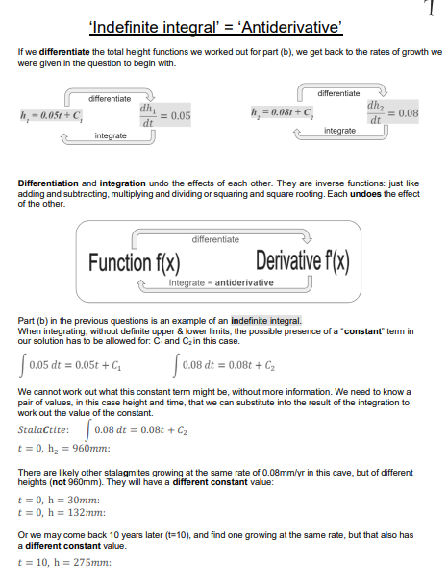  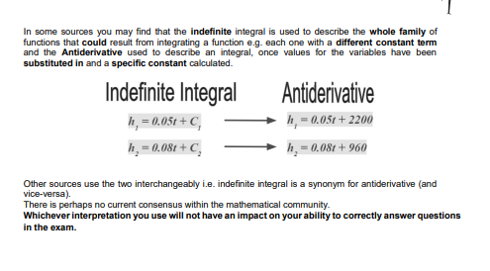

Friday | I am reviewing for paper 1 and paper 2 for the IB Math Exam. | I can show what I know for paper 1 and paper 2 for the IB Math Exam. | Pass Out  - Practice Exam  - Command Words  - Formula Packet | Students will be going through their practice exam highlighting command word in questions and put what is required for each question and looking through their formula packet and writing down any formulas they can find in their packet for each question. | We will be using the practice exam all week next week and reviewing for the exam.
*☐ Exit Ticket/Final Stretch Check ☒ Electronic Tools ☐ Dry Erase Boards – quick checks ☐ Turn & Talk Discussion (verbal responses) ☐ Teacher Observation – document Clipboard
☐ Quick Write/Draw ☐ Annotation ☐ Extended Writing ☐ Socratic Seminar ☐ Jigsaw ☐ Thinking Maps ☒ Worked Examples ☐ Other : ___________

